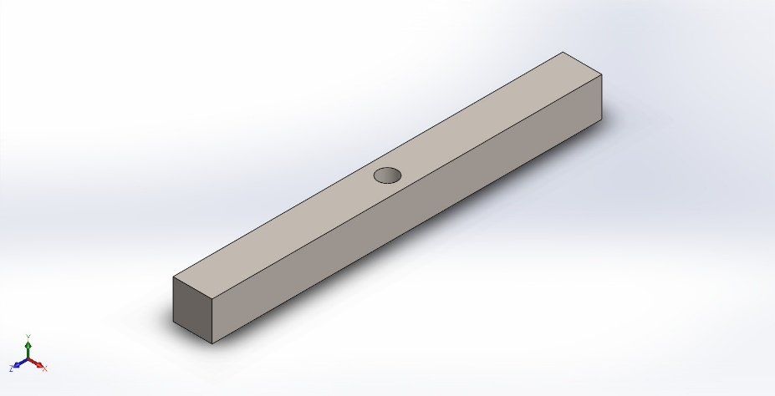
  Simulation of beam with hole
  Date: 17 April 2024
  Designer: Solidworks
  Study name: beam with hole
  Analysis type: Static
  Table of Contents
  Description 1
  Assumptions 2
  Model Information 2
  Study Properties 3
  Units 3
  Material Properties 4
  Loads and Fixtures 4
  Connector Definitions 5
  Interaction Information 5
  Mesh information 5
  Sensor Details 6
  Resultant Forces 6
  Beams 6
  Study Results 7
  Conclusion 9

Description
No Data

Assumptions

Model Information

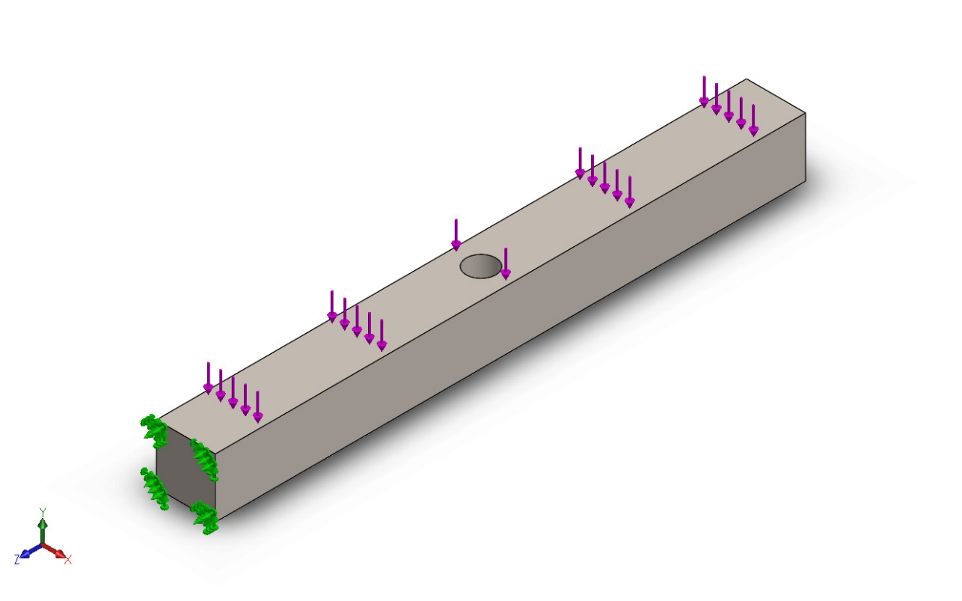
Model name: beam with hole
Current Configuration: Default
Solid Bodies
Document Name and Reference | Treated As | Volumetric Properties | Document Path/Date Modified
Cut-Extrude1  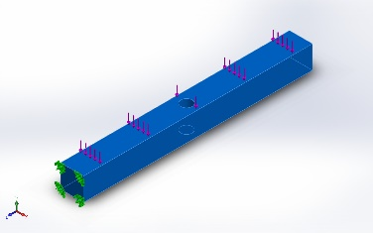 | Solid Body | Mass:75.4881 kg  Volume:0.00980365 m^3  Density:7,700 kg/m^3  Weight:739.783 N | C:\Users\user\OneDrive\Documenten\Adobe\beam with hole.SLDPRT  Apr 17 09:39:36 2024

Study Properties
Study name | beam with hole
Analysis type | Static
Mesh type | Solid Mesh
Thermal Effect: | On
Thermal option | Include temperature loads
Zero strain temperature | 298 Kelvin
Include fluid pressure effects from SOLIDWORKS Flow Simulation | Off
Solver type | Automatic
Inplane Effect: | Off
Soft Spring: | Off
Inertial Relief: | Off
Incompatible bonding options | Automatic
Large displacement | Off
Compute free body forces | On
Friction | Off
Use Adaptive Method: | Off
Result folder | SOLIDWORKS document (C:\Users\user\OneDrive\Documenten\Adobe)

Units
Unit system: | SI (MKS)
Length/Displacement | mm
Temperature | Kelvin
Angular velocity | Rad/sec
Pressure/Stress | N/m^2

Material Properties
Model Reference | Properties | Components
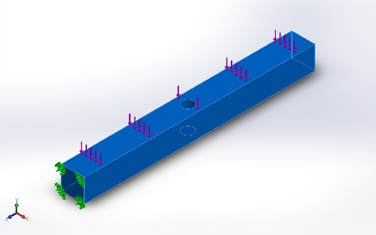 |  | SolidBody 1(Cut-Extrude1)(Part2)
  Name: | Alloy Steel
  Model type: | Linear Elastic Isotropic
  Default failure criterion: | Unknown
  Yield strength: | 6.20422e+08 N/m^2
  Tensile strength: | 7.23826e+08 N/m^2
  Elastic modulus: | 2.1e+11 N/m^2
  Poisson's ratio: | 0.28
  Mass density: | 7,700 kg/m^3
  Shear modulus: | 7.9e+10 N/m^2
  Thermal expansion coefficient: | 1.3e-05 /Kelvin
Curve Data:N/A

Loads and Fixtures
Fixture name | Fixture Image | Fixture Details
Fixed-1 | 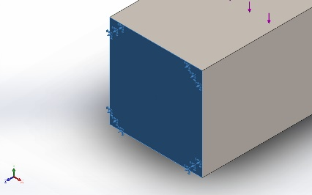
  Entities: | 1 face(s)
  Type: | Fixed Geometry
Resultant Forces
Components | X | Y | Z | Resultant
Reaction force(N) | 0.569031 | 9,999.94 | -0.0825195 | 9,999.94
Reaction Moment(N.m) | 0 | 0 | 0 | 0

Load name | Load Image | Load Details
Force-1 | 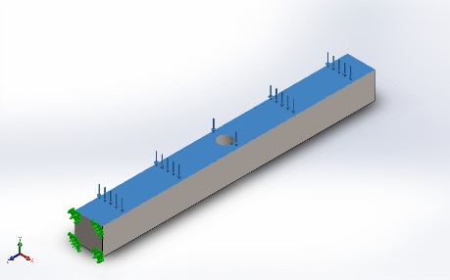
  Entities: | 1 face(s)
  Type: | Apply normal force
  Value: | 10,000 N

Connector Definitions
No Data

Interaction Information
No Data

Mesh information
Mesh type | Solid Mesh
Mesher Used: | Blended curvature-based mesh
Jacobian points for High quality mesh | 16 Points
Maximum element size | 21.4057 mm
Minimum element size | 7.13516 mm
Mesh Quality | High

Mesh information - Details
Total Nodes | 15544
Total Elements | 9896
Maximum Aspect Ratio | 4.8319
% of elements with Aspect Ratio < 3 | 99.7
Percentage of elements with Aspect Ratio > 10 | 0
Percentage of distorted elements | 0
Time to complete mesh(hh;mm;ss): | 00:00:02
Computer name:

Sensor Details
No Data

Resultant Forces

Reaction forces
Selection set | Units | Sum X | Sum Y | Sum Z | Resultant
Entire Model | N | 0.569031 | 9,999.94 | -0.0825195 | 9,999.94

Reaction Moments
Selection set | Units | Sum X | Sum Y | Sum Z | Resultant
Entire Model | N.m | 0 | 0 | 0 | 0

Free body forces
Selection set | Units | Sum X | Sum Y | Sum Z | Resultant
Entire Model | N | 0.804934 | -0.558834 | 3.36758 | 3.50725

Free body moments
Selection set | Units | Sum X | Sum Y | Sum Z | Resultant
Entire Model | N.m | 0 | 0 | 0 | 1e-33

Beams
No Data

Study Results

Name | Type | Min | Max
Stress1 | VON: von Mises Stress | 1.793e+03N/m^2  Node: 3158 | 3.227e+07N/m^2  Node: 4
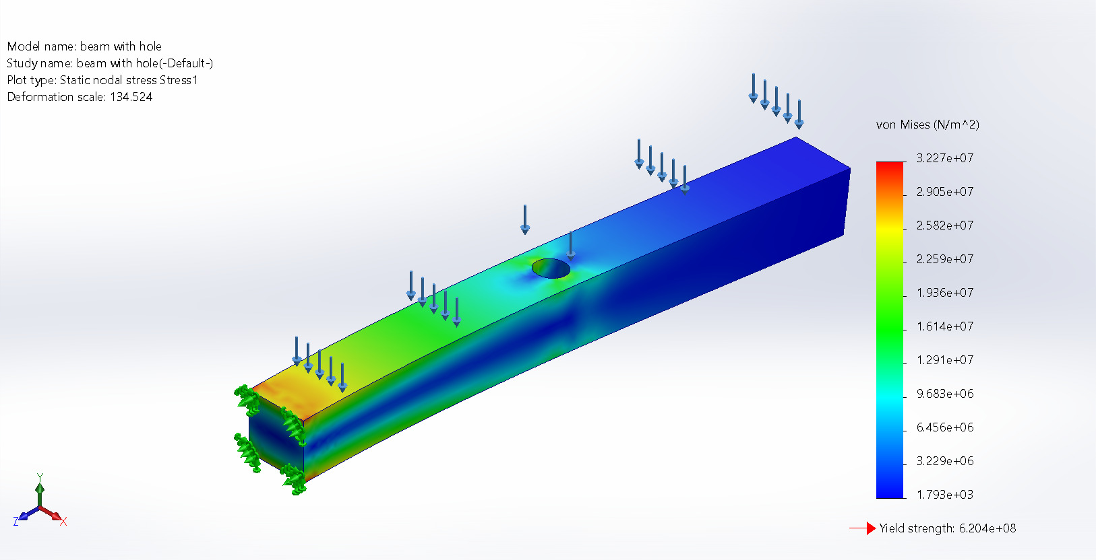
beam with hole-beam with hole-Stress-Stress1

Name | Type | Min | Max
Displacement1 | URES: Resultant Displacement | 0.000e+00mm  Node: 3 | 7.451e-01mm  Node: 9
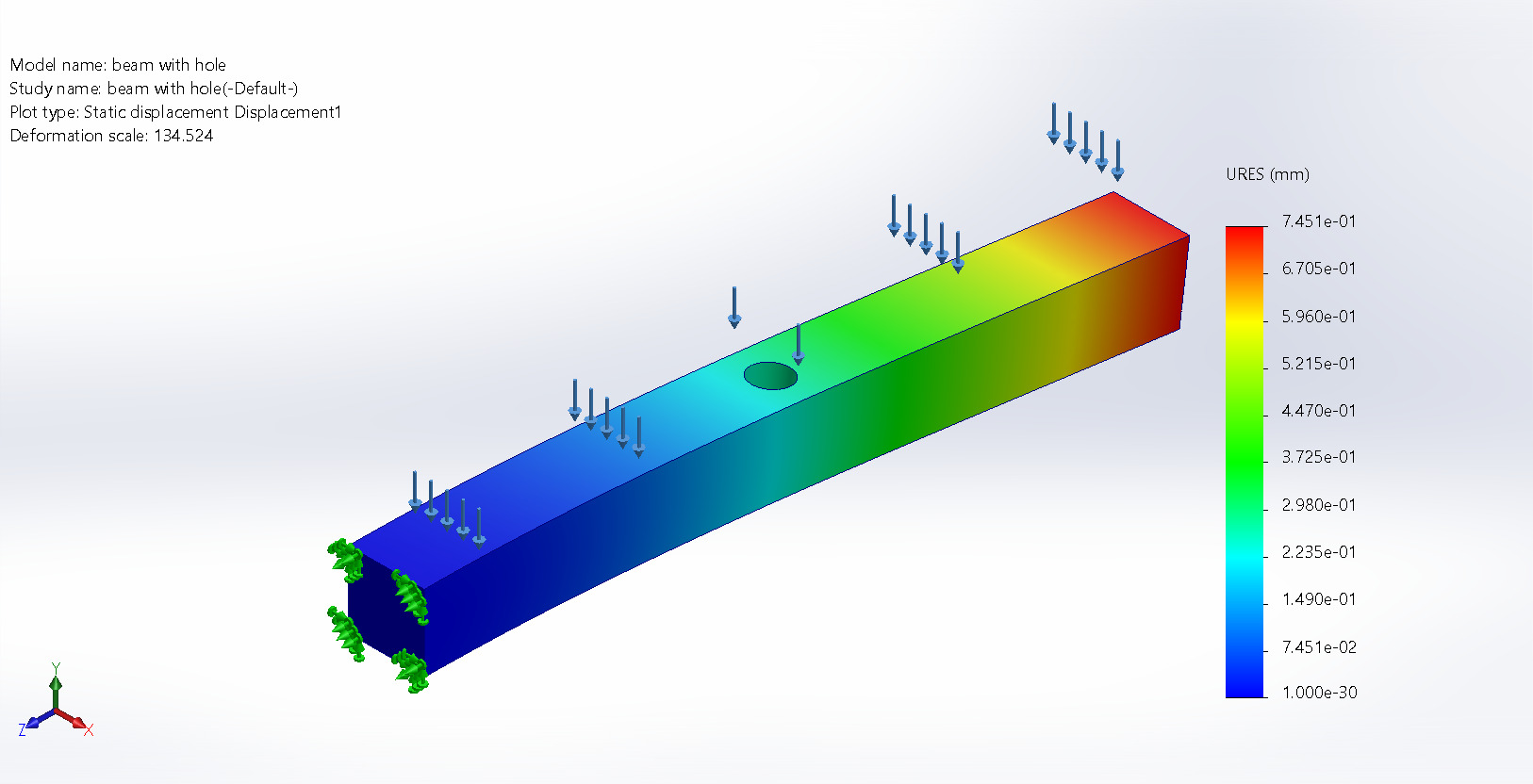
beam with hole-beam with hole-Displacement-Displacement1

Name | Type | Min | Max
Strain1 | ESTRN: Equivalent Strain | 2.818e-09  Element: 4303 | 1.103e-04  Element: 2793
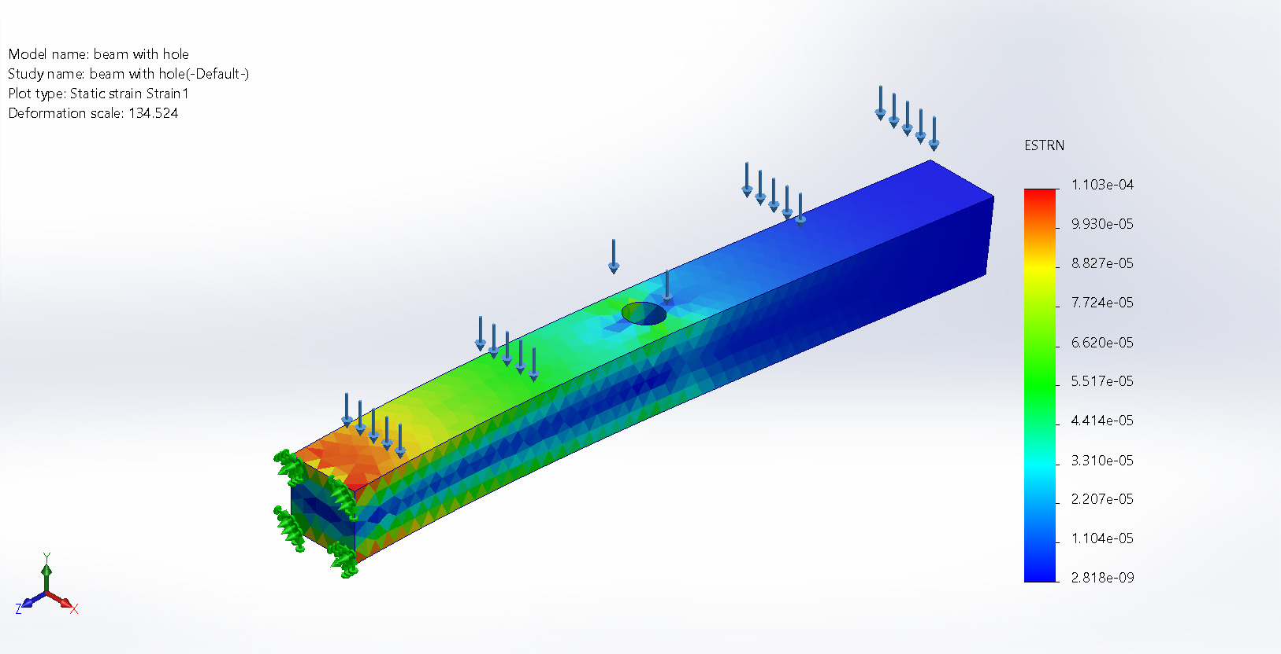
beam with hole-beam with hole-Strain-Strain1

Name | Type
Displacement1{1} | Deformed shape
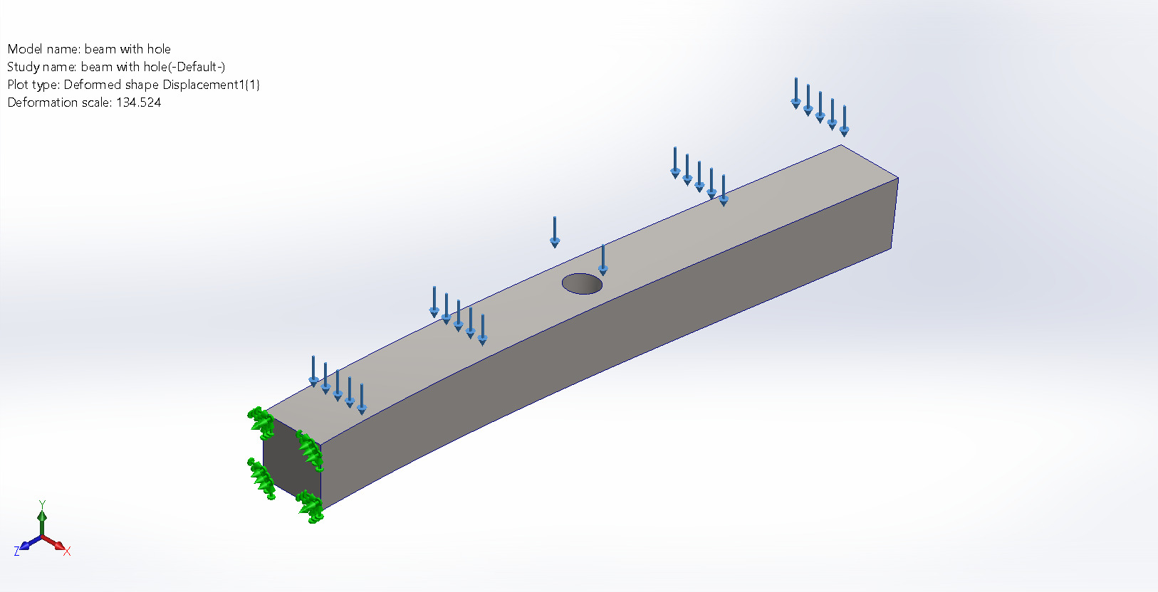
beam with hole-beam with hole-Displacement-Displacement1{1}

Conclusion

